E18-D80NK Infrared Obstacle Avoidance Sensor Module + Circuit Explanation
The E18-D80NK-N is a photoelectric sensor that integrates emission and reception. The emitted light is modulated before transmission, and the receiver demodulates the reflected light to produce the output. This effectively avoids interference from visible light. With the help of the lens, this sensor can detect objects at distances up to 80 cm. Due to the characteristics of infrared light, the maximum detection distance varies with object color: white objects can be detected farthest, while black objects can be detected at the shortest distance.
The obstacle detection distance can be adjusted using the potentiometer knob at the rear. This sensor features long detection distance, low sensitivity to visible light interference, low cost, easy assembly, and convenient use. It can be widely applied in robot obstacle avoidance, production-line counting, and many other scenarios. Example applications include automatic counting equipment for goods on production lines or passenger flow in supermarkets and buses, infrared speed measurement, multifunction reminders, and maze-solving robots.
I. Module Parameters
(1) Photoelectric sensor (photoelectric switch), NPN normally open
(2) Red: VCC +; Black: GND -; Yellow: OUT signal output (low level when an object is detected ahead, otherwise high level).
(3) Operating voltage: 5V DC
(4) Operating current: 10-15 mA
(5) Drive current: 100 mA
(6) Sensing distance: adjustable from 3 to 80 cm
(7) Color: orange-yellow
(8) Diameter: 18 mm
(9) Length: 45 mm
(10) Lead length: 25 cm.
(11) Current consumption: DC < 25 mA
(12) Response time: < 2 ms
(13) Detectable objects: transparent or opaque objects
(14) Ambient operating temperature: -25°C to +55°C
(15) Standard detectable object conditions: sunlight below 10000 LX, incandescent light below 3000 LX
(16) Housing material: plastic
II. Module Interface Description
(1) Brown wire: connect to 5V supply, VCC.
(2) Blue wire: connect to GND
(3) Black wire: digital output interface (0 and 1)
The interface schematic of the E18 infrared obstacle avoidance sensor module is shown below.

Interface schematic of the E18 infrared obstacle avoidance sensor module
The physical picture of the E18 infrared obstacle avoidance sensor module is shown below.
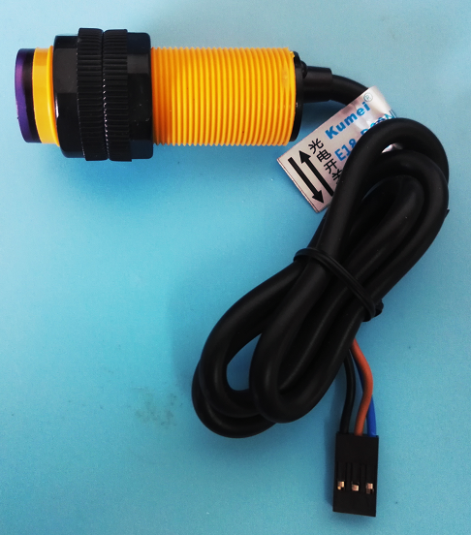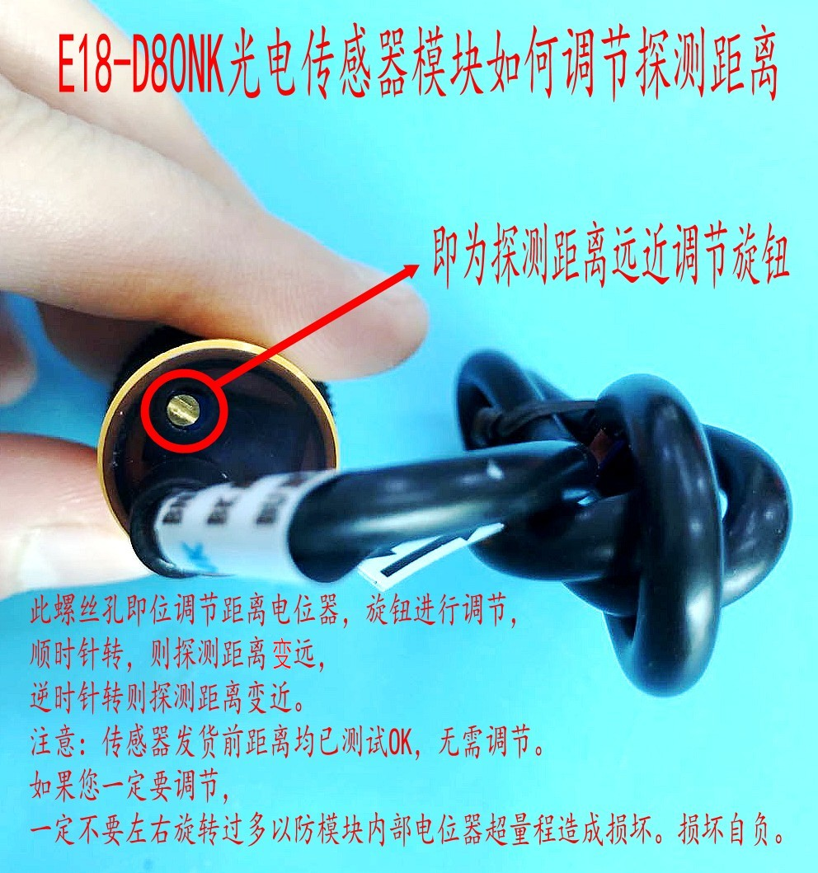
Physical picture of the E18 infrared obstacle avoidance sensor module

